|  |  |
| --- | --- |
| **العربية** | Electrical Engineering Department (EEC 271) Signals&Systems  Spring 2022 - 2023 |

Lab(2) report

|  |  |
| --- | --- |
| **Name** | **ID** |
| Mostafa Mohamed Abdel-Azeem Hassanen  Ahmed Abdel-Hakem Abdel-Salam Ali | 20011950  20010124 |
|  |  |
| **Section:** | 4 |
|  |  |
| **Department:** | **Electronics and Communication** |

Task1

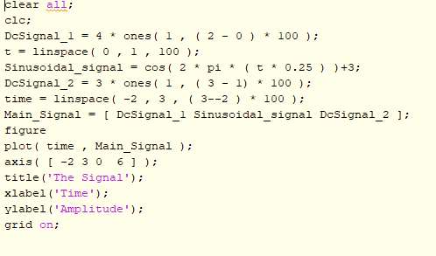**Code**  **Result**

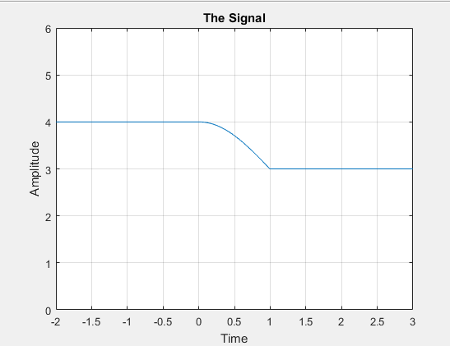

Task2

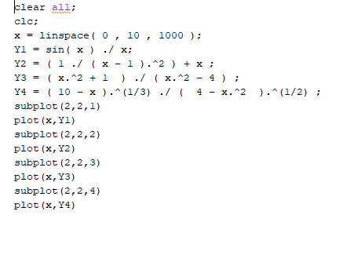**Code Result**

Task3

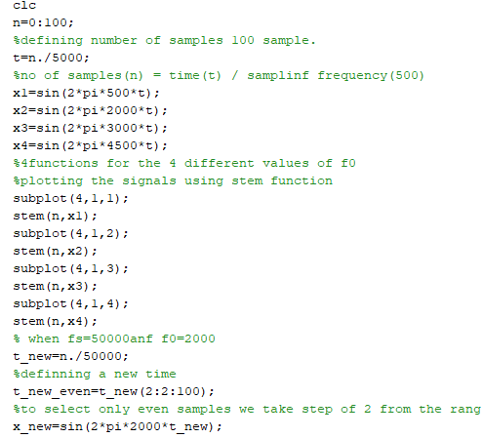**Code** **Result**

# **First comment**

# Similarities Differences

They have the same amplitude. Different number of samples.

They are all periodic Different accuracy due to samples .number.

# **Second comment**

1-frequency of x(n) is 2KHz

2-y(n) is periodic with frequency 2KHz

Task4

**Code**

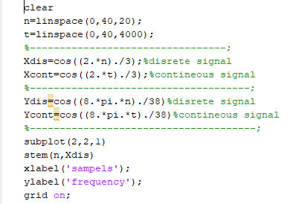

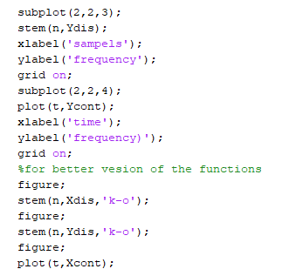

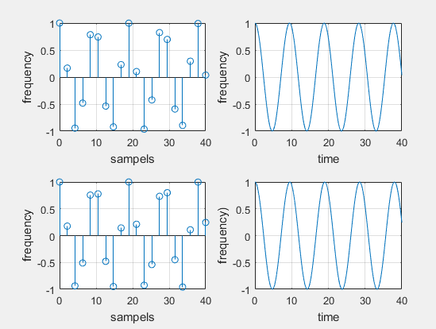**Result**

# **Comment:**

* The sequences are **periodic**
* In one period for the continuous signals it
* Makes 1cycle every 10 seconds

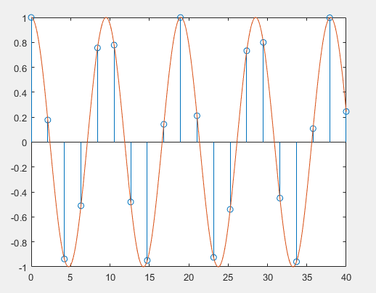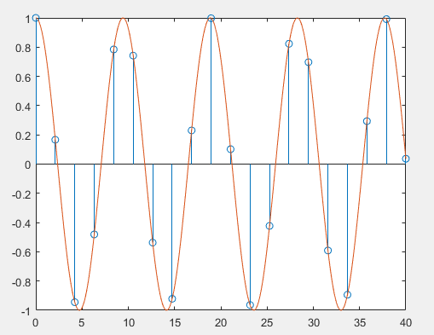

Task5

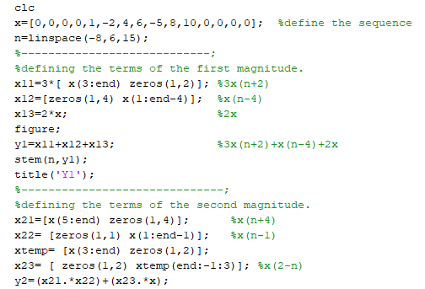Code Result

Task6

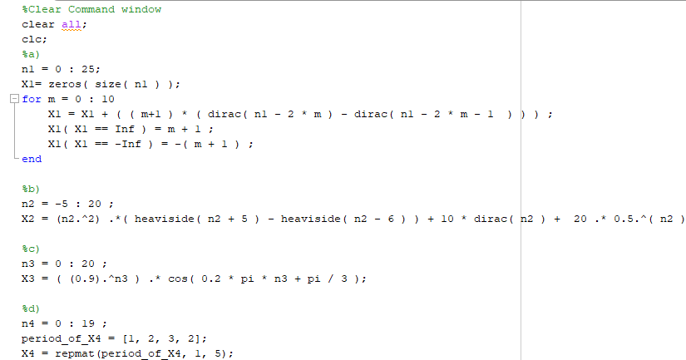**Code** **Result**

Task7

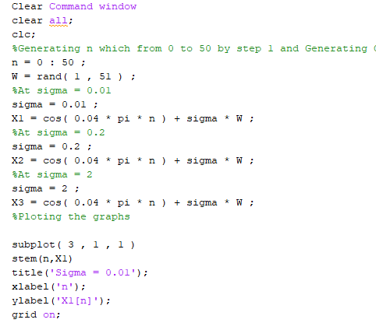**Code**  **Result**

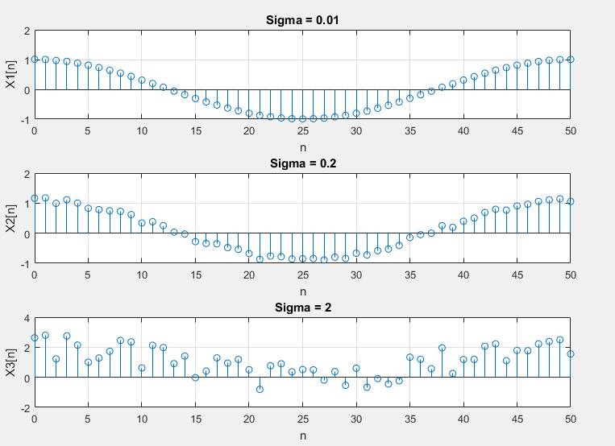

Task8

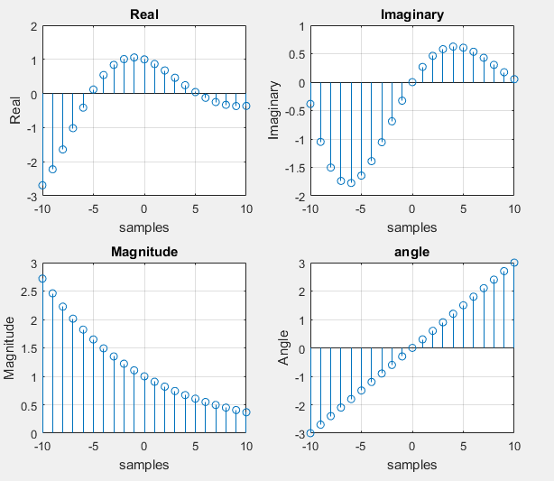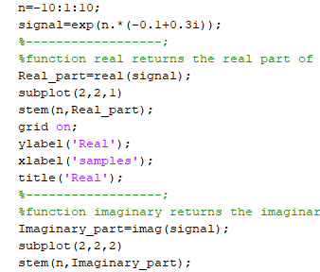**Code** **Result**

